Git Commands and Their Meaning
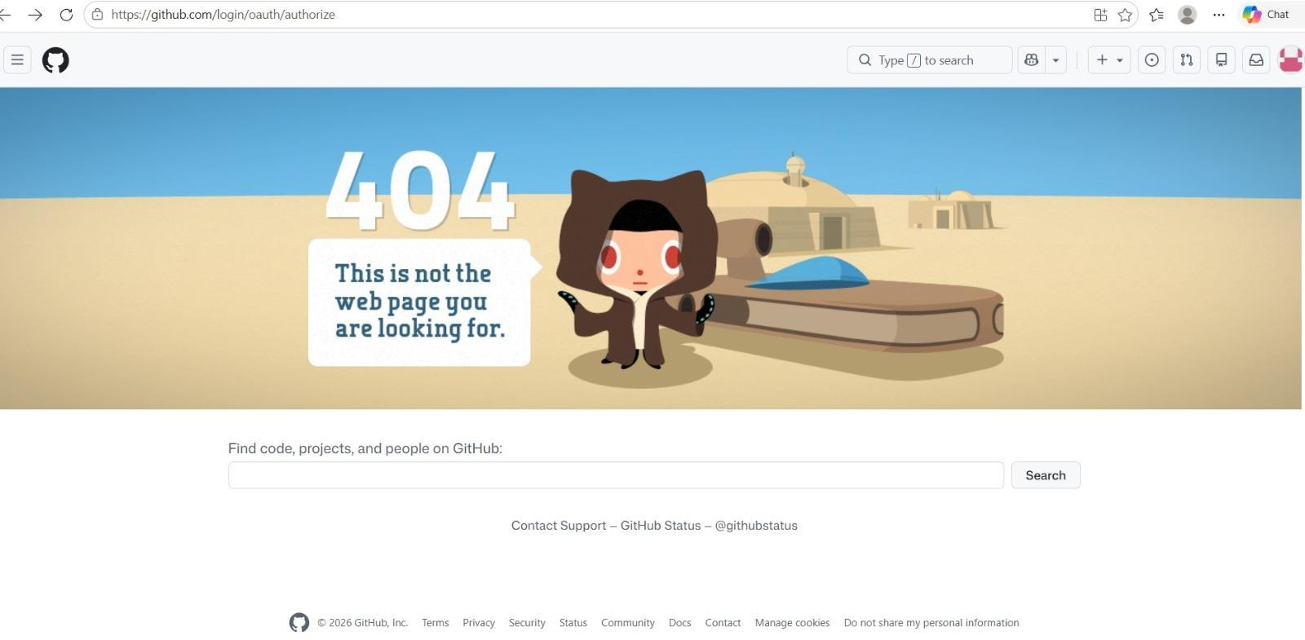

Introduction to Git

What is Git?
Git is a distributed version control system used to track changes in files, manage different versions of a project, and collaborate with other developers.

What is GitHub?
GitHub is an online platform that stores Git repositories and allows developers to share and collaborate on projects.

  - git --version

Purpose:
Checks the installed Git version.

  - git config --global user.name "Your Name"

Purpose:
Sets the username for Git commits.
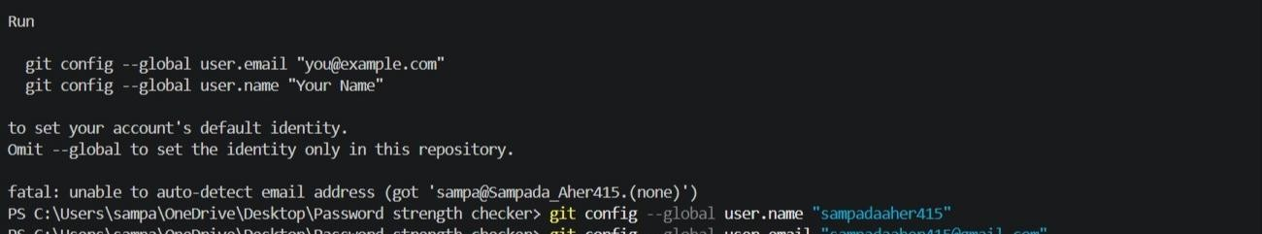

  - git config --global user.email "your@email.com"

Purpose:
Sets the email address associated with Git commits.
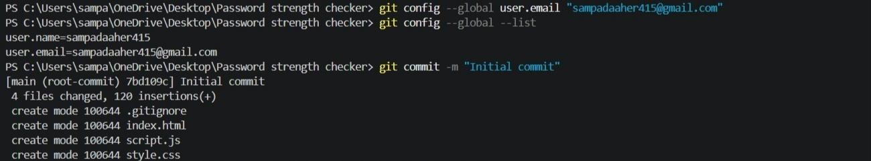

  - git init

Purpose:
Creates a new Git repository in the current folder.

git add .

Purpose:

git add is used to stage changes before creating a commit. It tells Git, "Include these specific changes in my next commit.
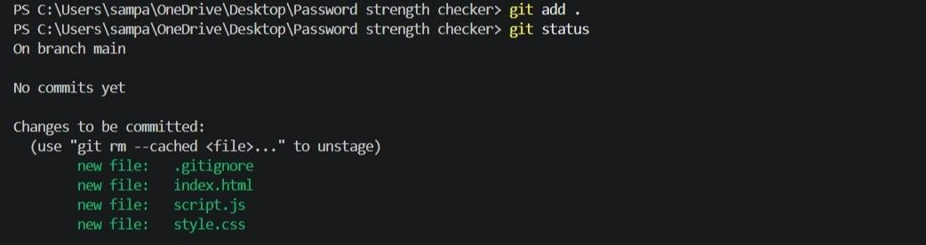

  - git status

Purpose:
Shows the current state of files.

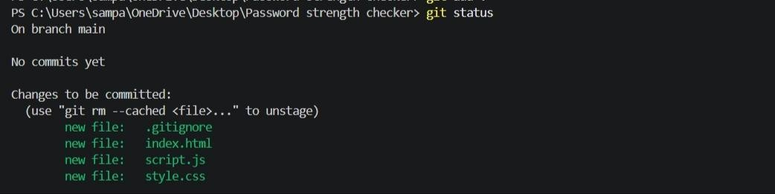

  - git add filename

Purpose:
Adds a specific file to the staging area.

  - git commit -m "message"

Purpose:
Saves changes permanently with a description.
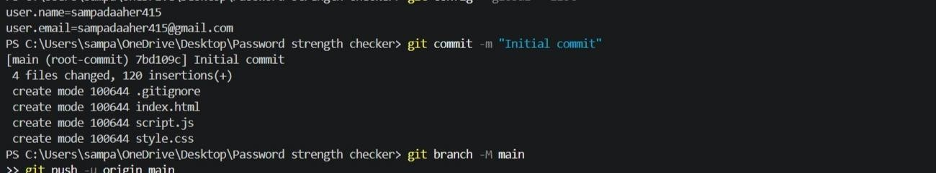

  - git remote add origin URL

Purpose:
Connects local repository with a GitHub repository.
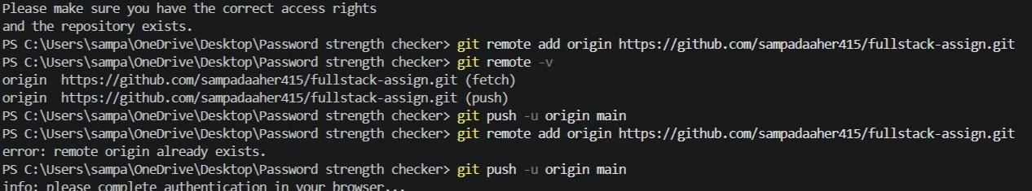
  - git remote -v

Purpose:
Displays connected remote repositories.

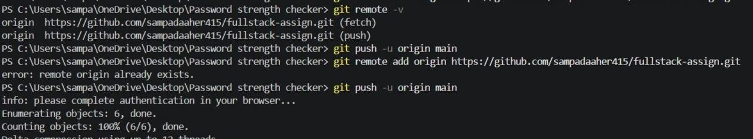

  - git remote remove origin

Purpose:
Removes the connection with a remote repository.

  - git push

Purpose:
Uploads committed changes to GitHub.

  - git push -u origin main

Purpose:
First-time push and connects local branch with remote branch.
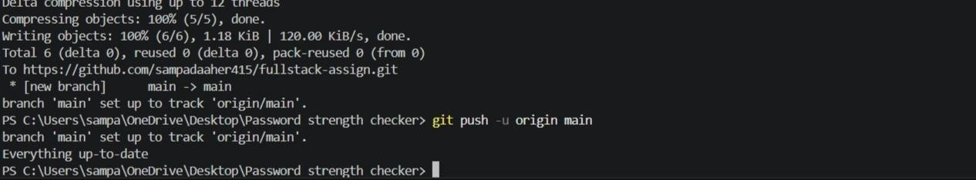

Complete command execution
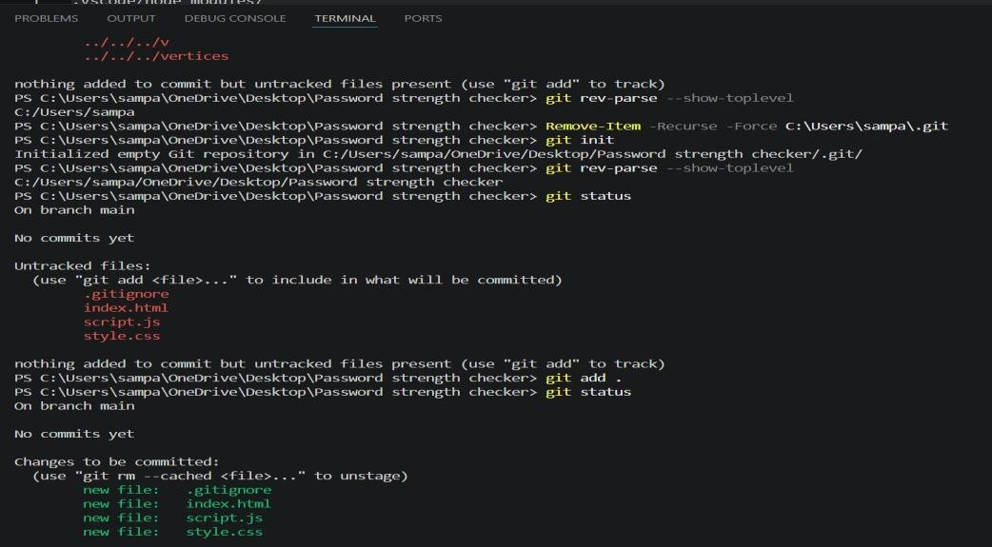

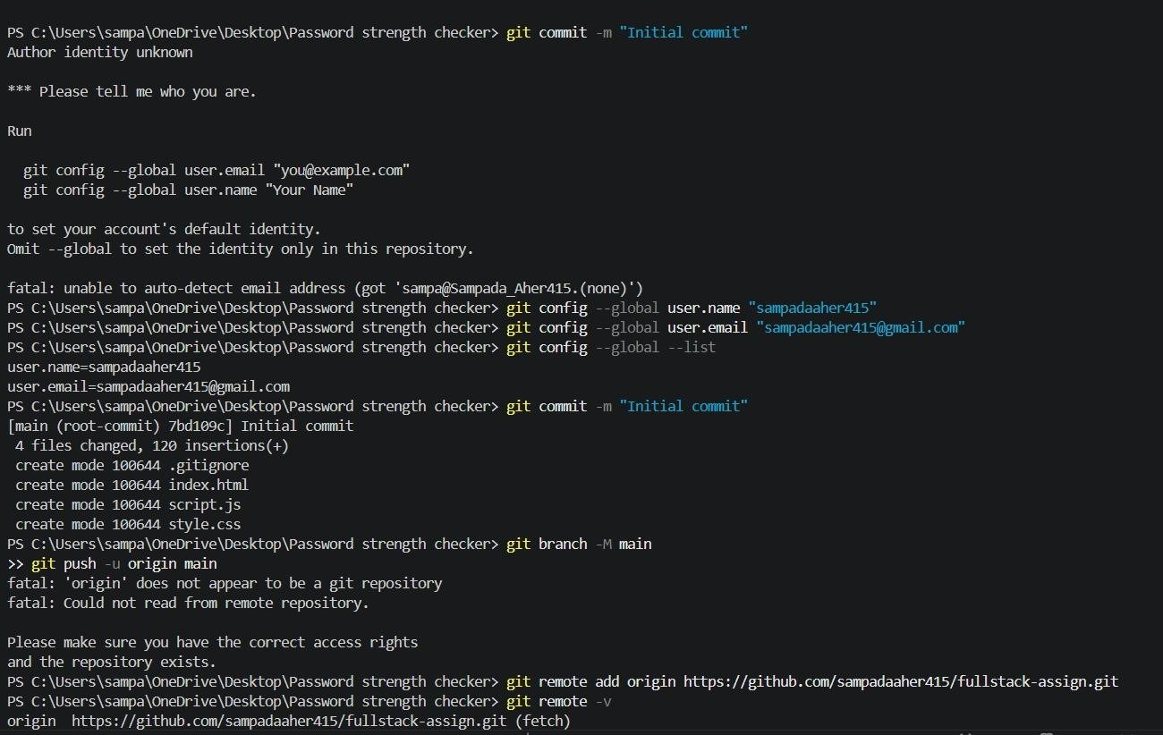
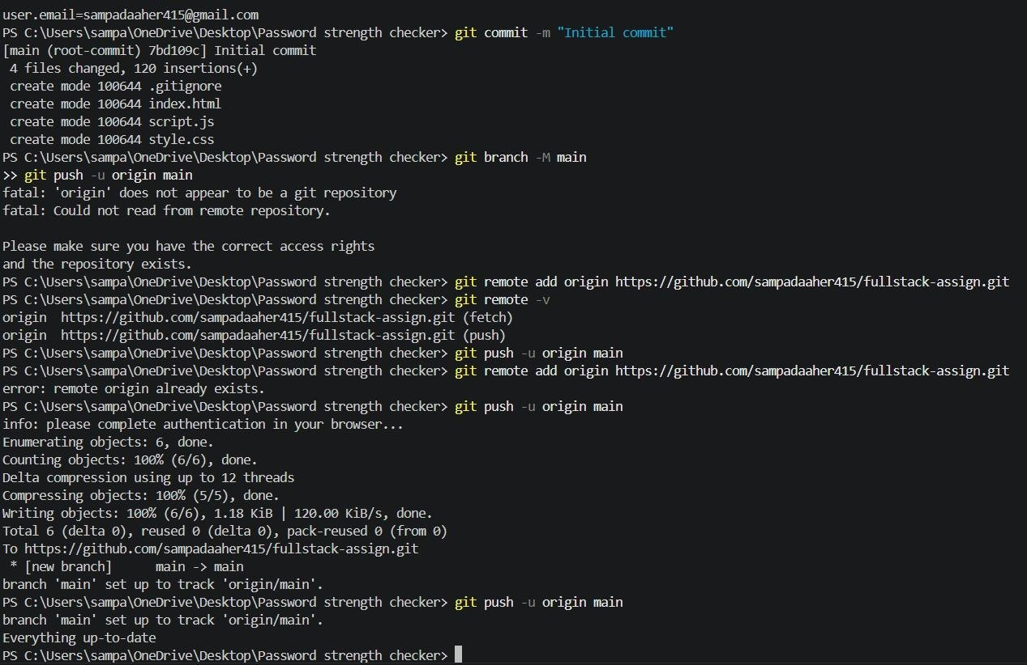

Authentaction Succeeded

If GitHub shows “Authentication succeeded”, it means your GitHub account has been successfully verified and your Git/GitHub login is working.

You can now use commands like:

    - git add .

    - git commit -m "first commit"

    - git push

So, Authentication succeeded = GitHub login/verification was successful.

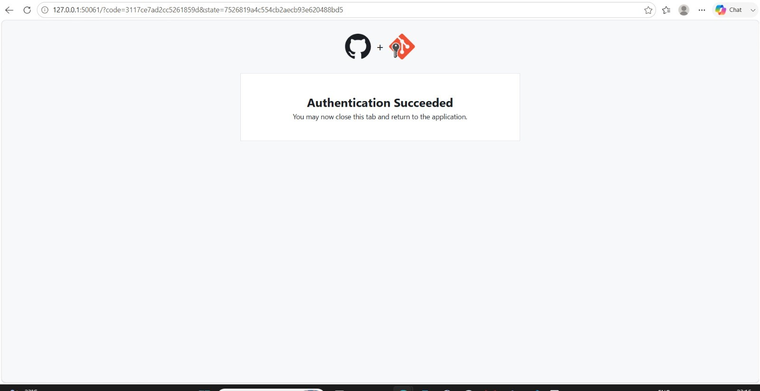

Push Repository
Push means uploading your local project/files from VS Code (your computer) to a GitHub repository. Use:
    - git add .
    - git commit -m "Initial commit"
    - git push origin main
Meaning:
  - git add . - Selects all changed files.
  - git commit -m "Initial commit" - Saves the changes locally.
  - git push origin main - Uploads the committed changes to GitHub.

After a successful push, refresh your GitHub repository and you should see your project files there.
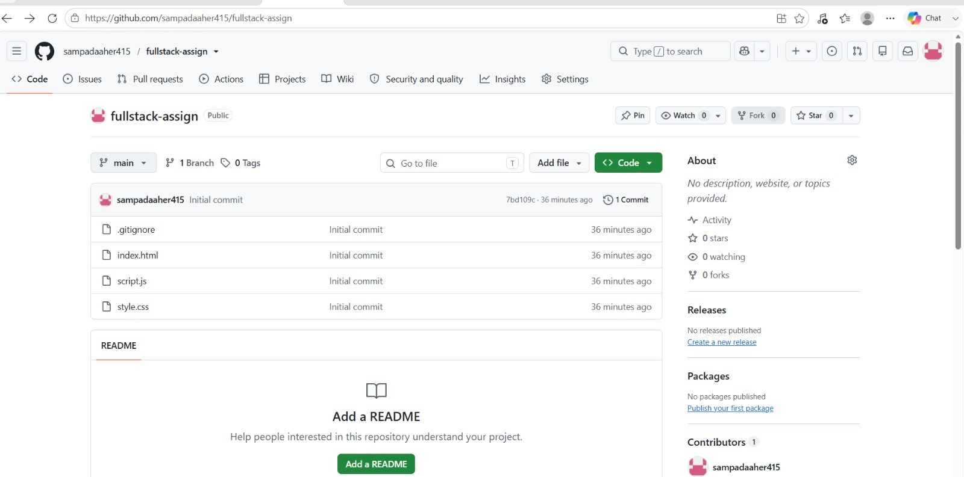

Conclusion:
Thus, we successfully linked Visual Studio Code with GitHub using Git commands. We configured Git, authenticated our GitHub account, initialized the repository, added and committed the files, and pushed the project to GitHub. Hence, the project was successfully uploaded and connected to the GitHub repository.

